Classification of Primates

# Prosimians

* **New world monkeys**: any of various arboreal anthropoid primates of the group or superfamily Platyrrhini, inhabiting forests from Mexico to Argentina
* More related to the earlier primates
* Continents include: Central/South America, and Mexico
  + Most primitive primates
* **Examples are: Lorises, Lemurs, and Tarsiers**
* Lemurs went through an adaptive radiation in Madagascar
  + **Adaptive radiation**: the diversification of a group of organisms into forms filling different ecological niches.
* **Strepsirhini**: mostly nocturnal
  + Suborder of primates that includes the lemuriform primates, which consist of the lemurs of Madagascar, galagos ("bushbabies"), pottos from Africa, and the lorises from India and southeast Asia.

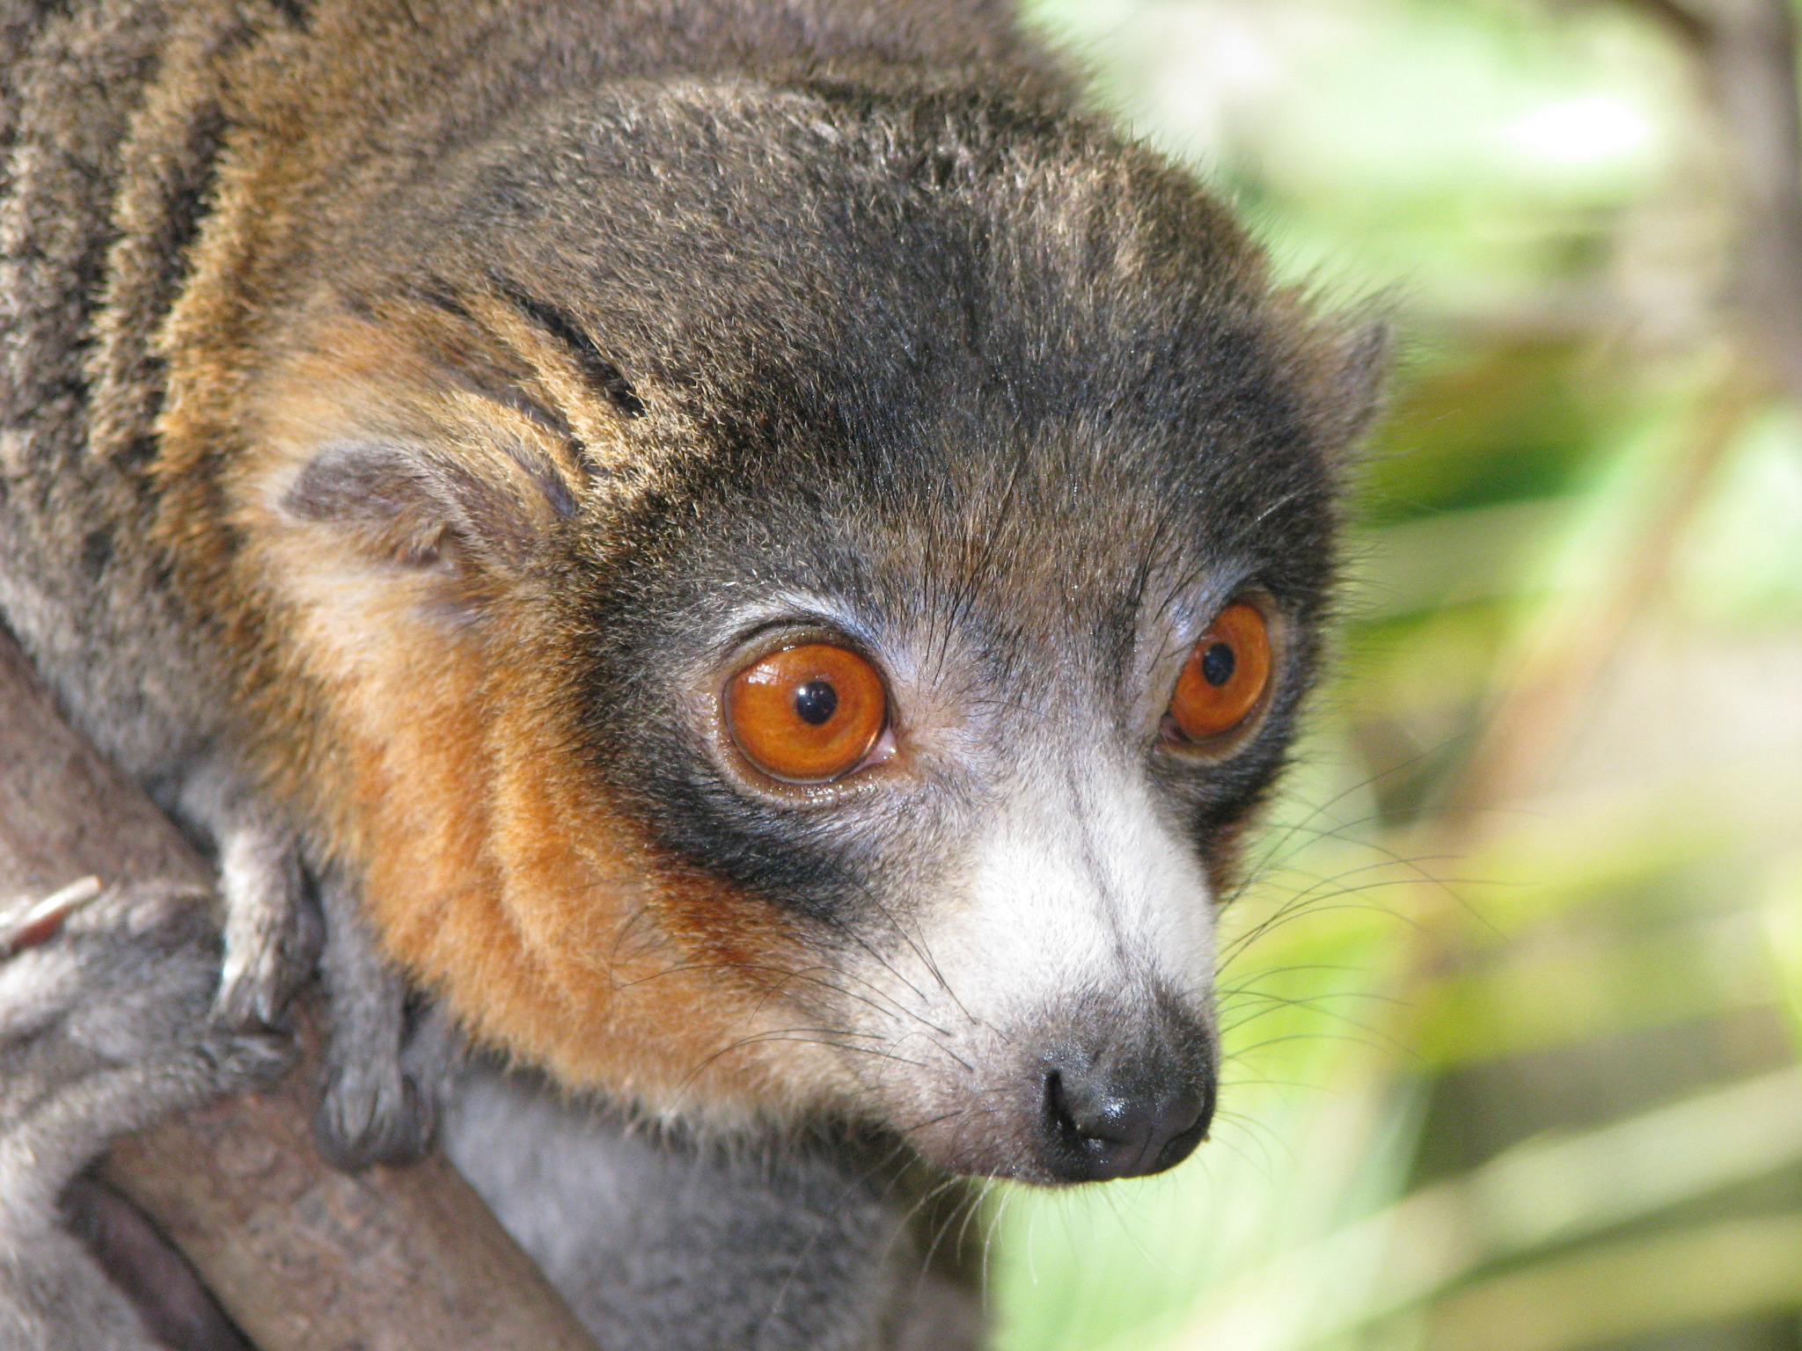

* Also known as Cercopithecidae which include **Colobines** and **Cercopithecines.**

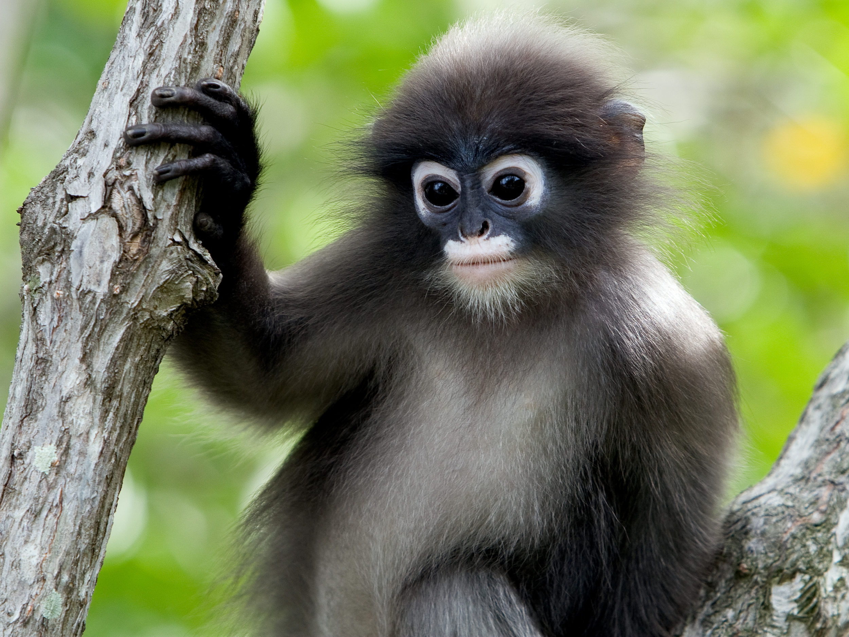 (Leaf monkey)

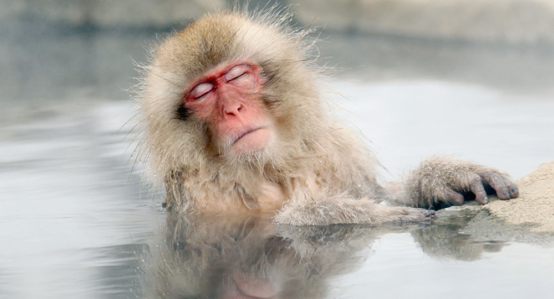 (Macaque Monkey)

# Anthropoids

* **Haplorhini**: chimps and humans

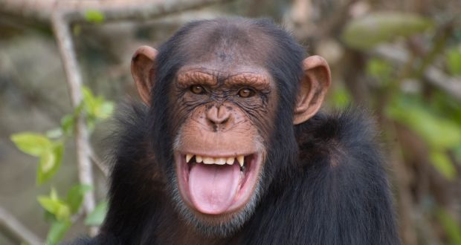

* + **Old World Monkeys**: any of various anthropoid primates of the family Cercopithecidae, of Africa, the Arabian peninsula, and Asia. Also known as Catarrhini.
* **Lesser Apes:** Gibbons and Siamangs

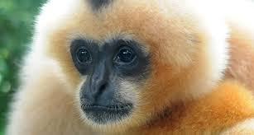

* **Great apes:** Orangutans, Gorillas, Chimpanzees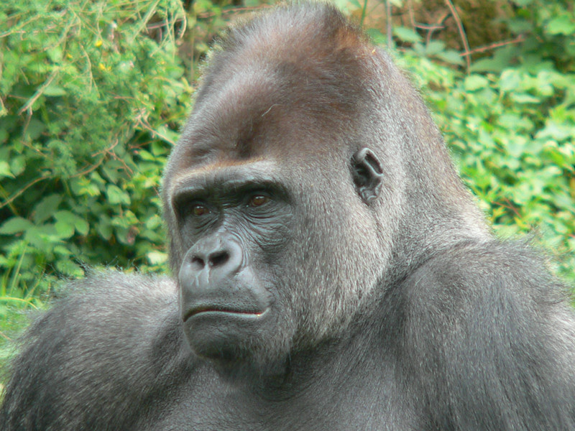 (Gorilla Gorilla)